SYSTEM ANALYSIS AND

DESIGN

UNIT – 1

System Study and System Development Life Cycle

Shree M. & N. Virani Science College (Autonomous)

ATMIYA Group of Institutions, Yogidham Gurukul, Rajkot.

Priyank Doshi

Asst. Professor (MCA, MSc.(Math) )



System

.

System is an organized relationship among the functioning units

or components to achieve predefined goal.

.

.

.

.

i.e. Car, Computer, Bank etc.

System consisted of man, machine and method.

Try to find out other Examples of System.

Justify, How a Software ( system / Application ) is a system ?

Shree M. & N. Virani Science College (Autonomous)

ATMIYA Group of Institutions, Yogidham Gurukul, Rajkot.

Priyank Doshi

Asst. Professor (MCA, MSc.(Math) )



Identify System, Subsystem, Component &

Modules.

VIRANI SCIENCE

COLLEGE

MANAGEMENT

SYSTEM

system

ACCOUNTING (1.0)

LIBRARY (2.0)

SPORTS (3.0)

ACADEMIC (4.0)

Sub system

MAKE

PAYMENTS(1.2)

RECEIVING FEE(1.1)

PURCHASE (1.3)

X

Modules

Component

(1.3.1)

Y

(1.3.2)

Shree M. & N. Virani Science College (Autonomous)

ATMIYA Group of Institutions, Yogidham Gurukul, Rajkot.

Priyank Doshi

Asst. Professor (MCA, MSc.(Math) )

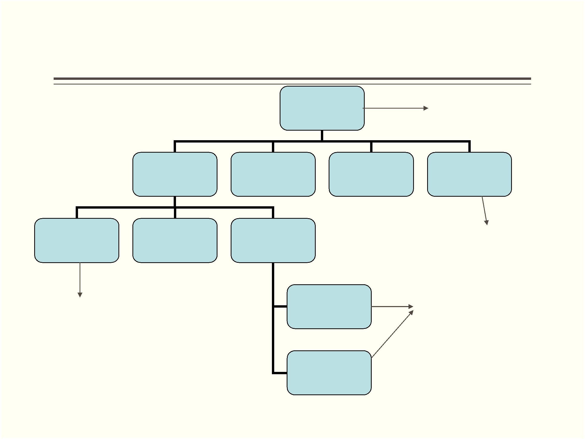

**Business System**

.

Any business is generally established for Profit Maximization and

Cost minimization. Business system may have different sub

systems like accounting, marketing, purchasing, production,

inventory etc.

.

Each sub system may have its functional units using that they

works. Business is not only production of goods but it may be

service providers, Consultants etc. Like any system it talks

inputs and gives output to their customers or clients.

Shree M. & N. Virani Science College (Autonomous)

ATMIYA Group of Institutions, Yogidham Gurukul, Rajkot.

Priyank Doshi

Asst. Professor (MCA, MSc.(Math) )



System Types

.

.

.

.

Physical Vs. Abstract

Tangible Vs. Intangible

Open Vs. Closed

Man Made Information System

Shree M. & N. Virani Science College (Autonomous)

ATMIYA Group of Institutions, Yogidham Gurukul, Rajkot.

Priyank Doshi

Asst. Professor (MCA, MSc.(Math) )



System Characteristics

.

**Organization**

Organization means structure and order. It is the arrangement of components to

achieve goal. Organization chart can be used to show structure and order.

.

**Interaction**

Functioning units must interact with each other for specific purposes. Marketing must

interact with production department for the information about products.

.

**Interdependence**

Component depends on each other. For example engine of vehicle depends on the

fuel tank.

.

**Integration**

It describes the relationships between different components and level of bindings.

**Central Objective**

.

It is pre-defined goal. The goal of vehicle is to reach at its destination with safety.

Shree M. & N. Virani Science College (Autonomous)

Priyank Doshi

Asst. Professor (MCA, MSc.(Math) )

ATMIYA Group of Institutions, Yogidham Gurukul, Rajkot.



System Study

.

.

A detailed **study** to determine whether, to what extent, and how

automatic data-processing equipment should be used.

This system study also includes a detailed analysis of the

existing system and a design of the new system, including in

depth detailing of the development of the system specification. It

is this study that will provide a basis for the selection of

equipment to be used in the project.

Shree M. & N. Virani Science College (Autonomous)

ATMIYA Group of Institutions, Yogidham Gurukul, Rajkot.

Priyank Doshi

Asst. Professor (MCA, MSc.(Math) )



Analysis starts Using –

output, Input, Storage, Process

Output

Input

Storage

Process

Shree M. & N. Virani Science College (Autonomous)

Priyank Doshi

Asst. Professor (MCA, MSc.(Math) )

ATMIYA Group of Institutions, Yogidham Gurukul, Rajkot.

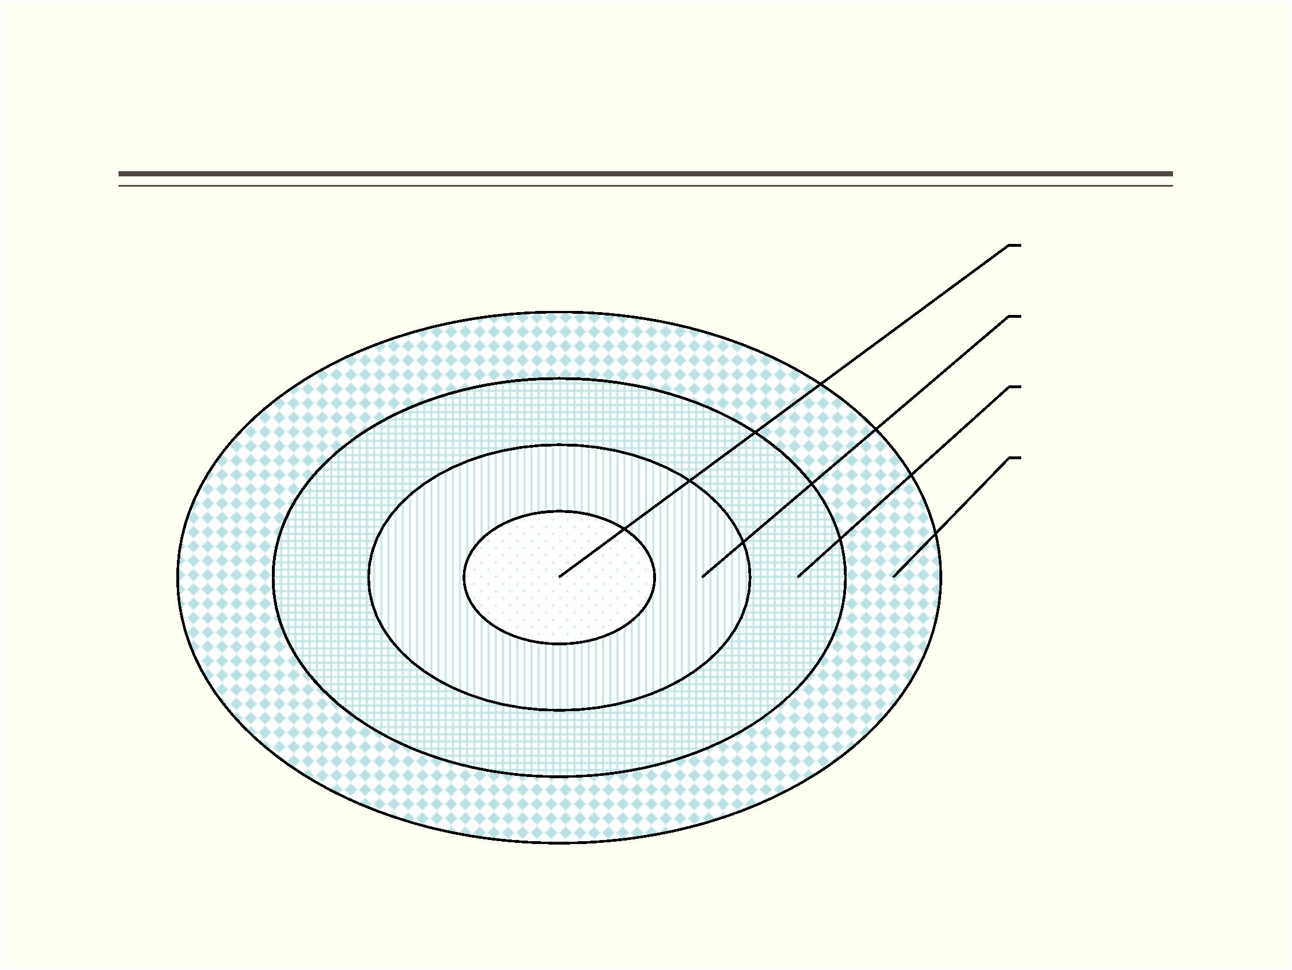

Elements of System Analysis

**Outputs:** It is the goal of system. Set of User requirements.

**Inputs:** Input depends on output. It must be accurate. It must be taken from

source. It must be provided at the time it requires. Late inputs are useless. Input

must be in proper format. Format of input must be fixed in advanced. Input must

not be too costly.

**Files:** Data can be stored in files. Files are nothing but they are tables to store

records. Files can stores inputs, intermediate processed data or final results. Files

can be used to store historical data.

**Processes:** To convert input into output we must write code and theses code uses

logic. Processes are nothing but programs written in any programming language.

Shree M. & N. Virani Science College (Autonomous)

Priyank Doshi

Asst. Professor (MCA, MSc.(Math) )

ATMIYA Group of Institutions, Yogidham Gurukul, Rajkot.



System Approach

.

The systems approach to problem solving used a systems

orientation to define problems and opportunities and develop

solutions. Studying a problem and formulating a solution involve

the following interrelated activities:

.

.

.

.

.

Recognize and define a problem or opportunity using systems thinking.

Develop and evaluate alternative system solutions.

Select the system solution that best meets your requirements.

Design the selected system solution.

Implement and evaluate the success of the designed system.

Shree M. & N. Virani Science College (Autonomous)

ATMIYA Group of Institutions, Yogidham Gurukul, Rajkot.

Priyank Doshi

Asst. Professor (MCA, MSc.(Math) )

